**Our Town Ceduna/Far West Community Grants**

Our Town Ceduna/Far West is inviting community groups to apply for a Community Grant.

The emphasis of this granting opportunity is to **build community connections**.

**Here were the big messages we heard from community last year:**

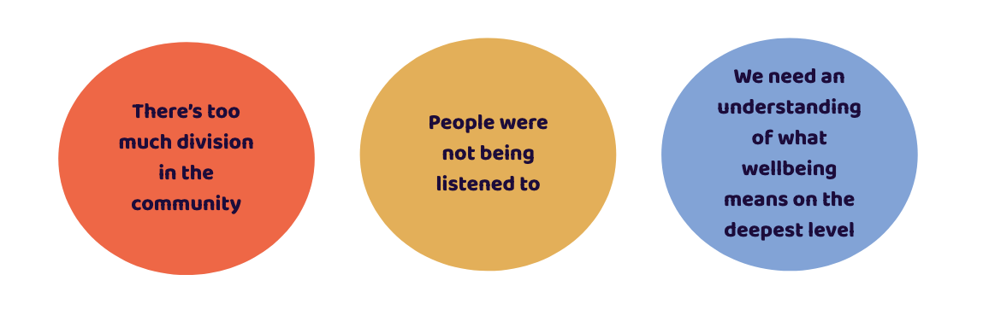

**We are looking for ideas to address what we heard from the Community.**

Through working with Community last year, we developed a set of guiding Principles about how we can work differently as a Community.

|  |  |  |  |
| --- | --- | --- | --- |
|  |  |  |  |
| **Focus on**  **wellbeing** | **Culturally**  **inclusive** | **Movement &**  **momentum** | **Recognition & acknowledgement** |
| We operate with a dynamic charter that keeps our focus on wellbeing and strengths to build on. We create opportunities to have community voice heard on multiple levels. | We share messages that are culturally inclusive and create understanding. We communicate in multiple languages and find ways to identify and overcome barriers to wellbeing. | We build movement and momentum through growing trusting relationships that reach far into community and across its many sectors. We actively include all aspects of our community including business and industry | We create new connections and breakdown divisions through recognizing shared history and relationships. We acknowledge the past to move forward truthfully. We hold open and honest dialogue about the past and the effect on the present with the aim of creating a different narrative to move forward. |

**As part of the application process there will be an interview with the Community Grants Team.**

***During this chat…*** Our team can talk to you more about what we heard from the community and why we came to the idea of Community Granting. We would be hoping to hear from you about your idea - to see if it is a natural fit**.**

**Tell us about your idea….**

1. What is your idea?
2. How will this idea engage community members?
3. How do you know this is what the community wants?
4. How will this make a difference? What change do you think this will lead to for our

community?

1. Who will be involved in bringing this idea to life?
2. How will this idea help break down barriers/divisions?
3. In what way does your idea align with the Our Town Ceduna/Far West Principles (see page 1).
4. What support will you need to bring this idea to life?
5. Would you be happy to share what you learn along the way with the Our Town team?

**Thank you for completing your idea template!**

**Please return to Sandy Taylor - Team Lead** / Call 0427 097 584 / E[mail](mailto:otceduna@gmail.com) [admin@ourtownceduna.com.au](mailto:admin@ourtownceduna.com.au)